Update, Thanksgiving Weekend 2018

We opened 2018 by watching the Rose Bowl Parade live in seats that cousin Craig Snodgrass reserved for us. It was an amazing experience, with live music, floats tens of feet away from us, and a beautiful warm day to watch the parade.

Olivia returning as a sophomore at Presentation High School: and performing at the top of the class. She continues to learn violin. During the summer of 2018, she went independently to Argentina for nearly three weeks visiting Vanesa Echeveste, Tio Jorge and Tia Coca, Primos Natalio and Matias, and a former Au Pair Cintia.

Will started at Bellarmine College Prepatory as a freshman. He joined the Cross Country team, and is settling into a tough academic rigor at Bell. He had an epic trip to Colorado for two weeks during the summer, including rafting the Class 3 Royal Gorge, backpacking the Maroon Bells, and Summiting Mount Shavano: a 14er that is 14,205 feet above sea level. Will was elected Senior Patrol Leader of his Troop, and was inducted into the Order of the Arrow.

Henry is maturing into a young man. He has an active Scouting life, attending two Scout Camps during the summer earning enough Merit Badges to reach the Star Rank. He was recently elected Patrol Leader of the Sharks. He is doing extremely well in Kumon, advancing beyond his grade level in both Math and Reading. He participated in the Regina Pacis Exciting Reciting Poetry recital. He also enjoyed Camp Sacred Heart with his brother Will.

Mark also had fun this last summer, as he joined his Dad and Elizabeth on a week trip to Philmont Scout Ranch. He is taking Piano, active in Vivace Youth Chorus, and scored a Bronze Award at Kumon for being above his grade level. He comes to FarmX to visit with Dad often, and has enjoyed building KiwiCo projects monthly. He also recited a poem at Exciting Reciting, and received a perfect score for his recital from the judges.

Ellie is just becoming an amazing young girl. She is so engaging and thoughtful, and loved by all her siblings. She also came with Mark and Dad to Philmont during the summer, and enjoyed being a “small fry”. She became a Junior Philmont Ranger, and wants to return to Philmont. She’s learning what IWTGBTP means already at age four.

Dad was nominated and was confirmed in 2018 to become a Distinguished Eagle Scout at the birthday weekend of Scouting on February 9, 2019. Only about 70 Eagle Scouts are honored in the United States each year with this Award.

Dad also attended Philmont for the first time since 1982, and took a national class in Scouting Alumni relationships.

In late September, we rallied as a family, and took professional photographs together for the first time in years.
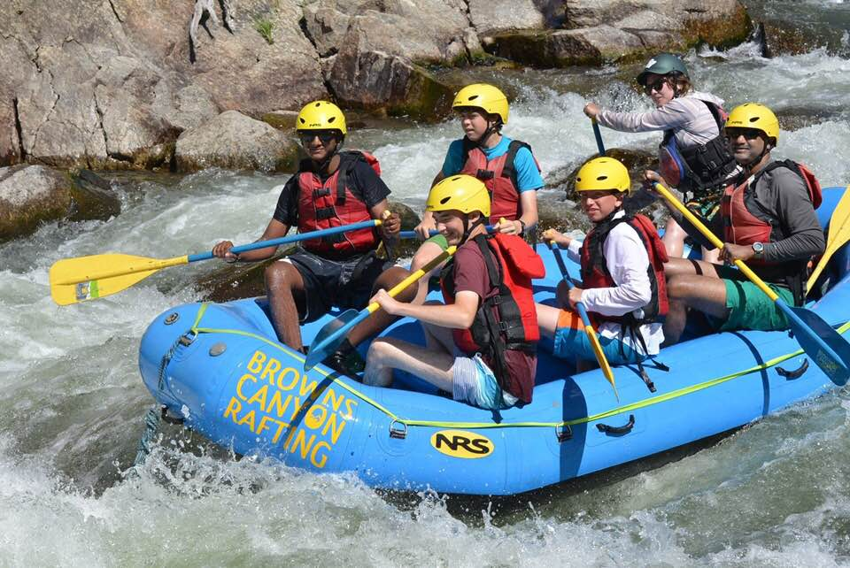

Will (in white shirt) rafting the Royal Gorge, Colorado, July 2018
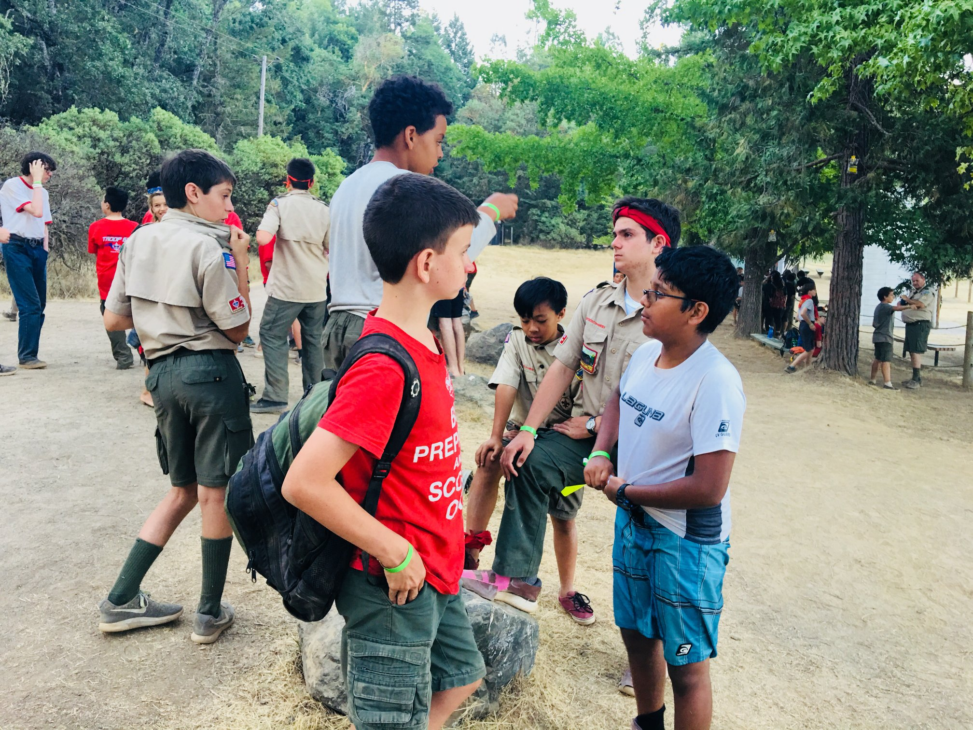

Henry (foreground) at Camp Wente, July 2018
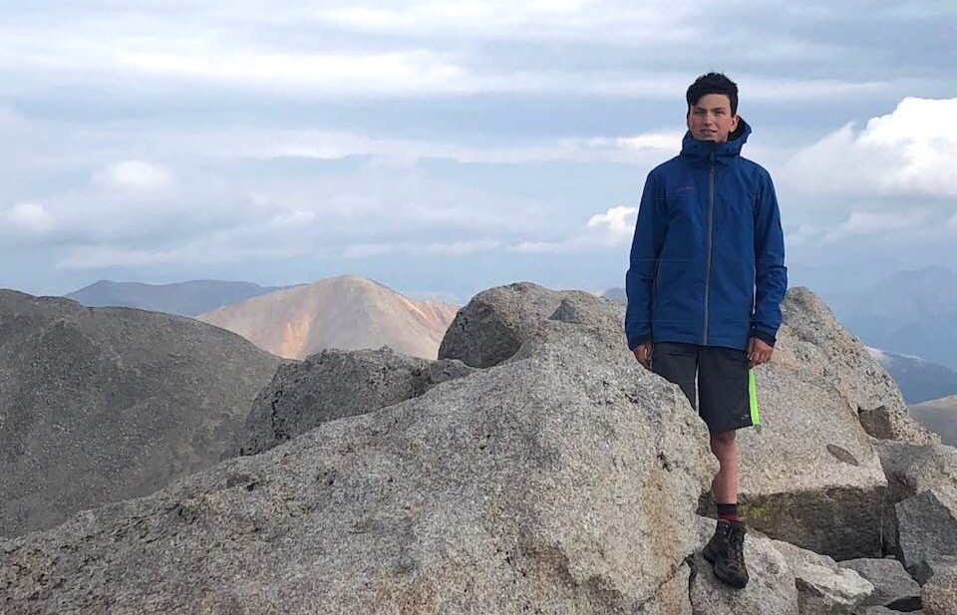

Will on Top of Mount Shavano, 14,205 feet, Colorado // August 3, 2018
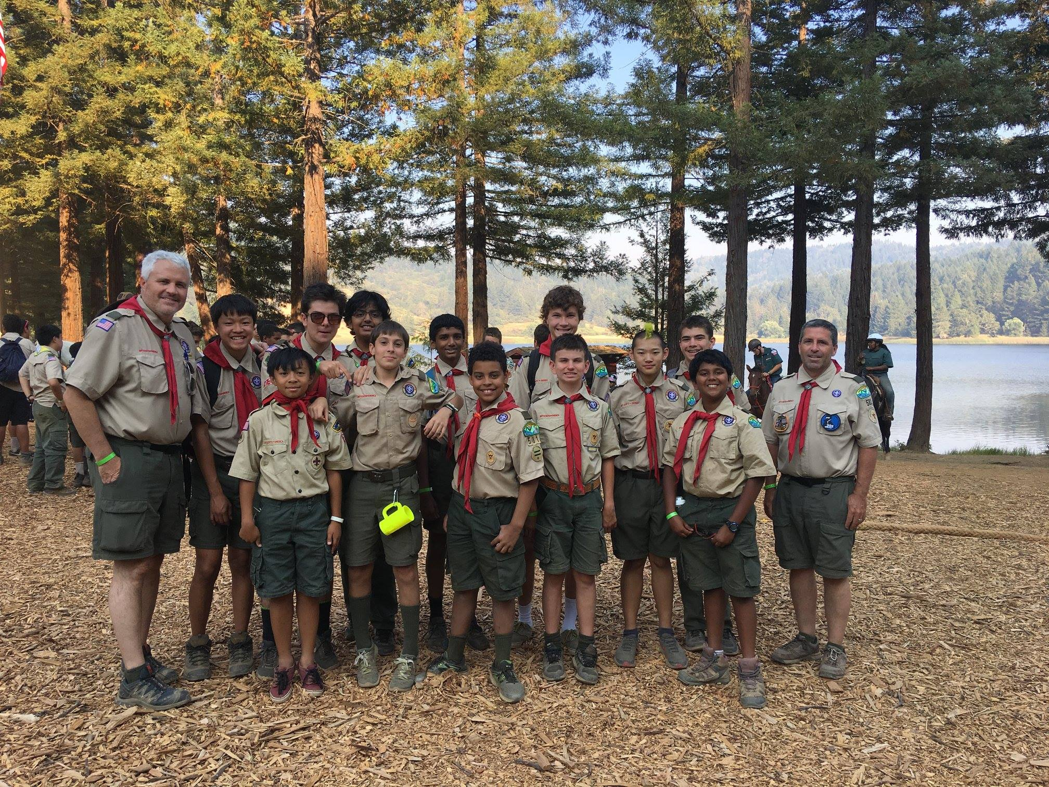

Henry and Troop 581 at Camp Wente, July 2018
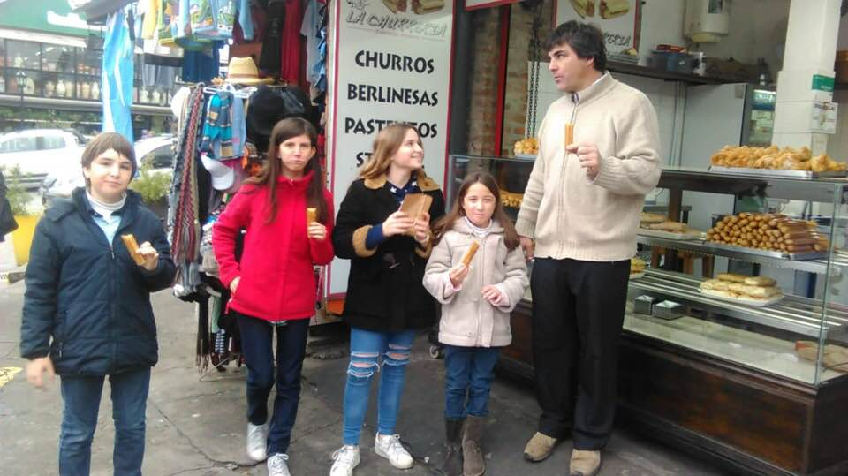

Olivia’s trip to
Argentina to be
there for Vane’s
son being born,
and
visiting family
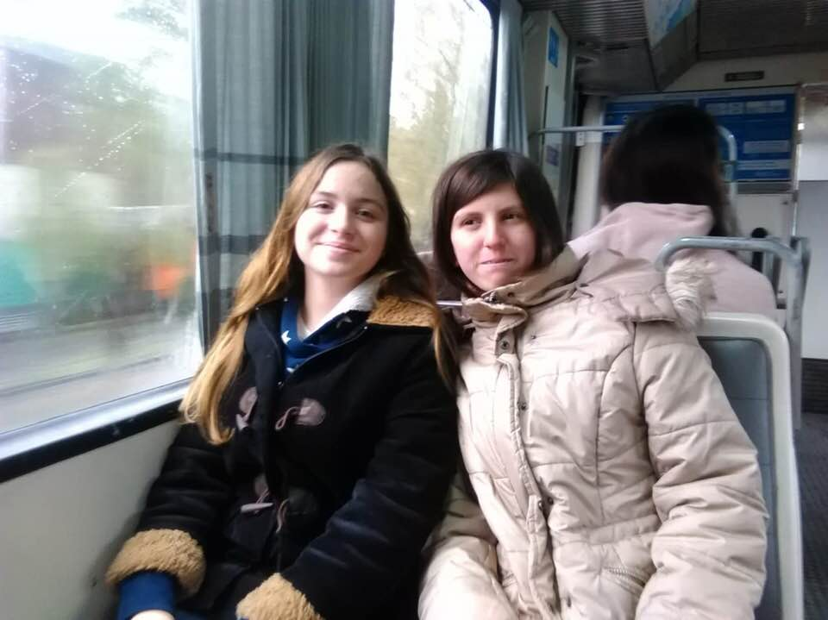
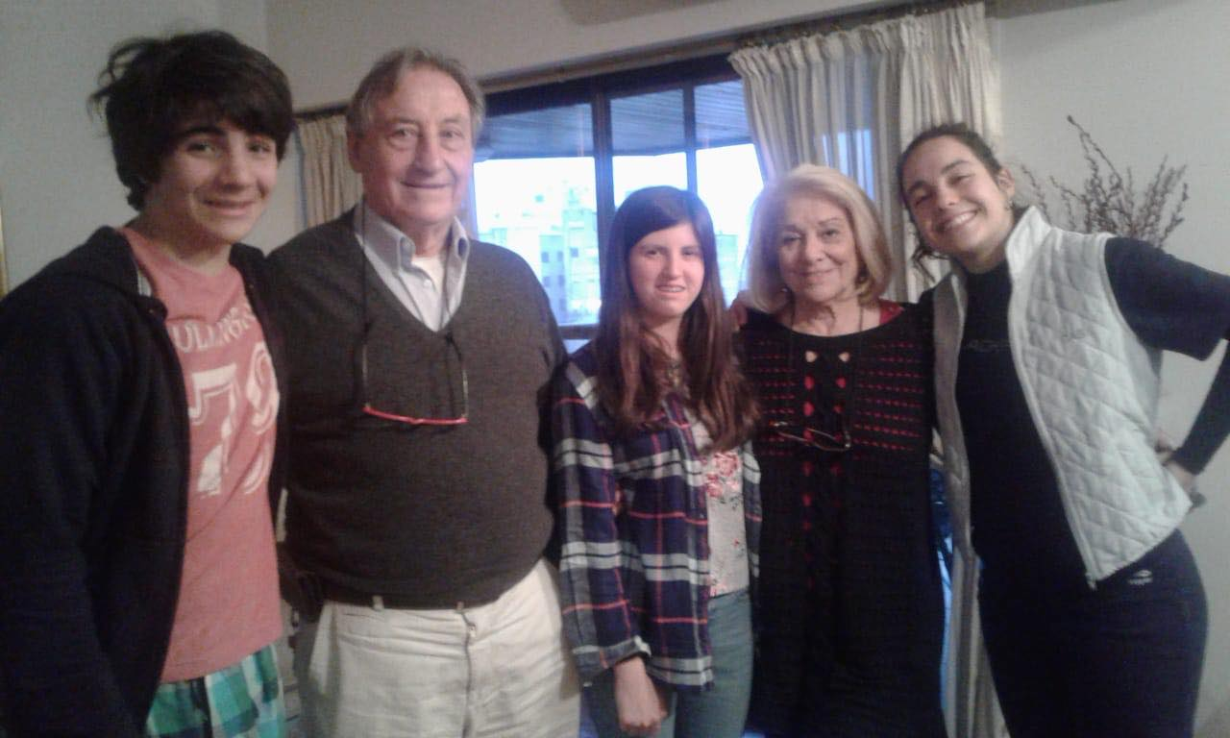
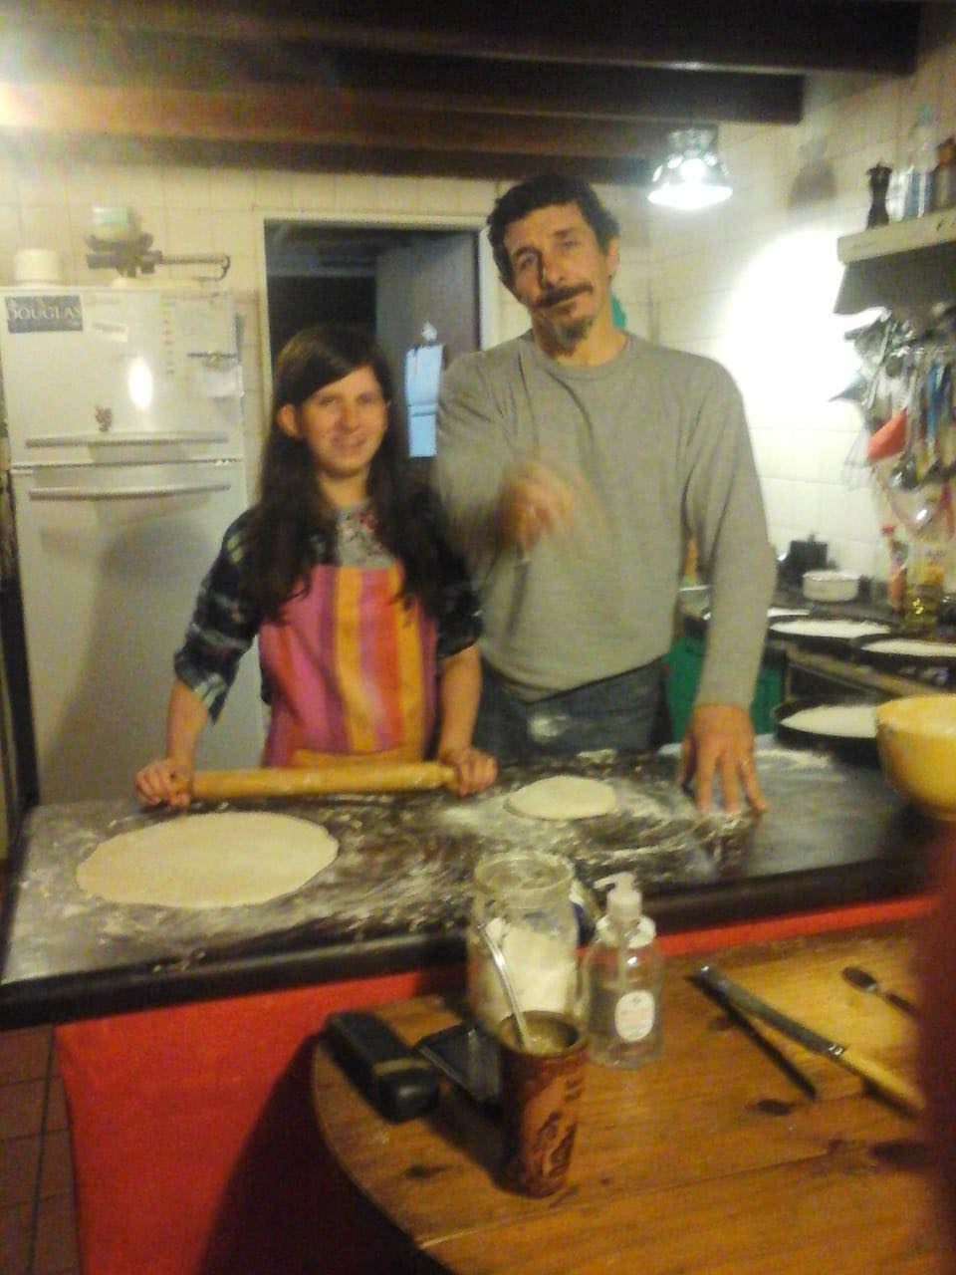
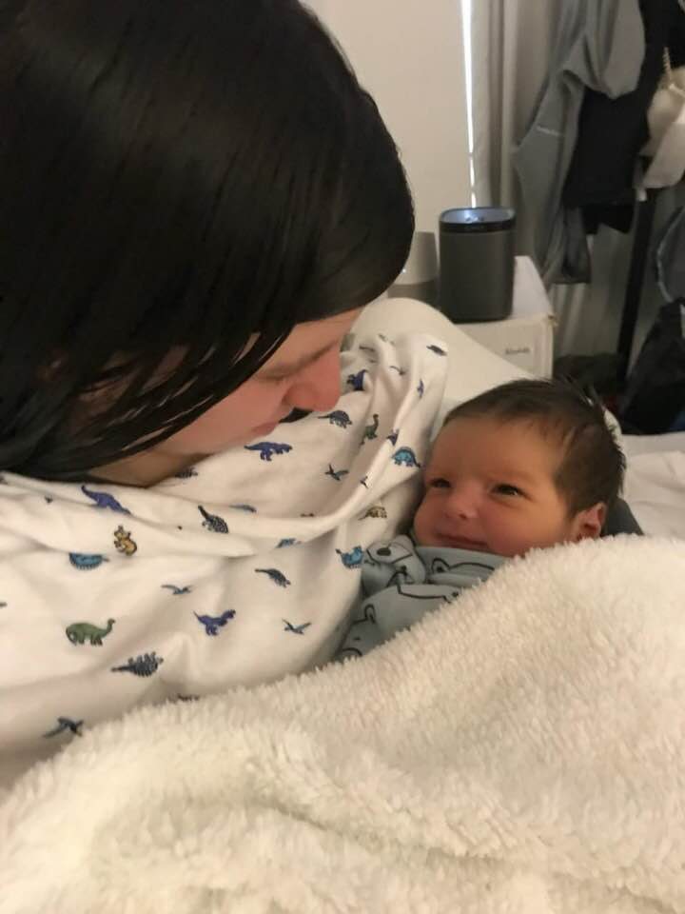
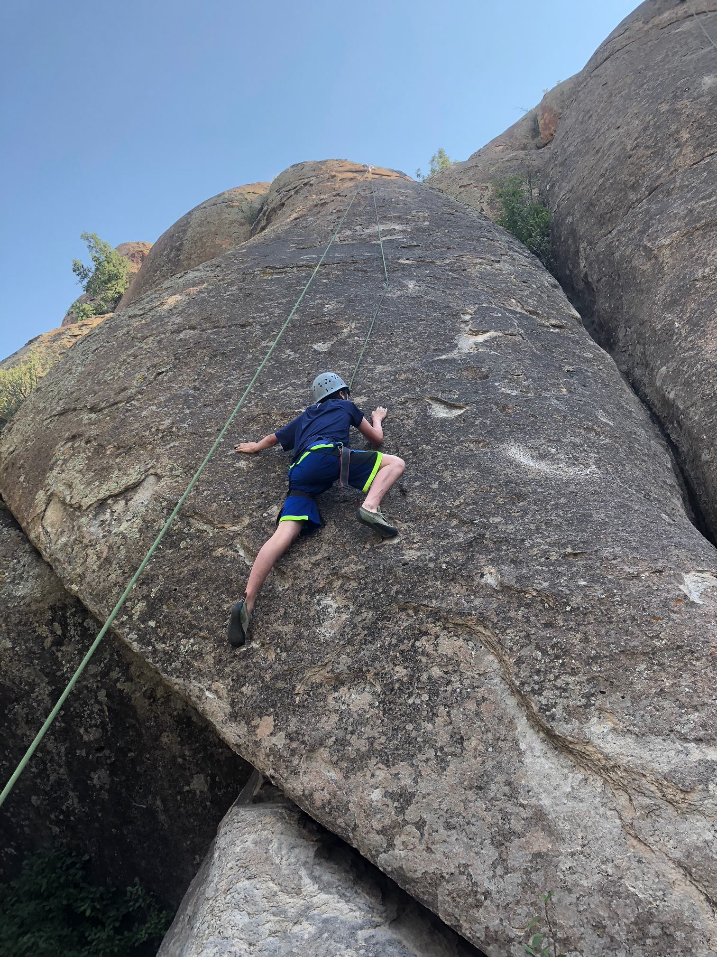
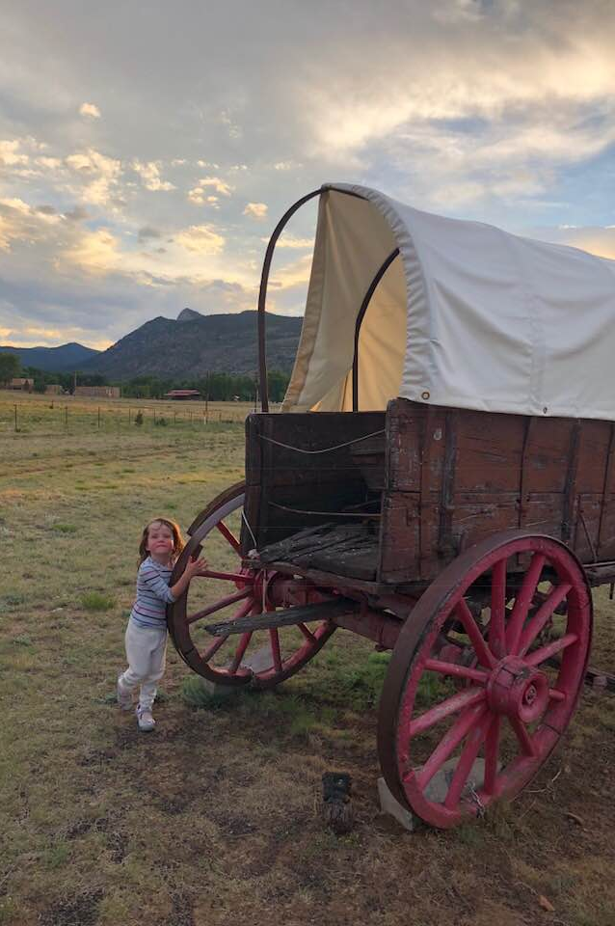
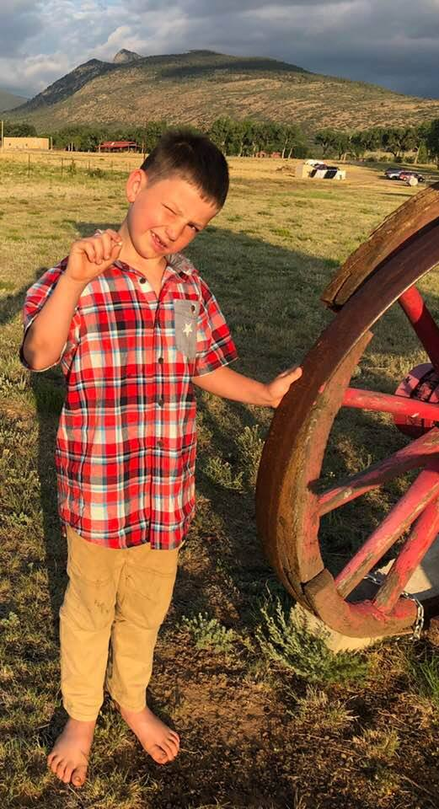
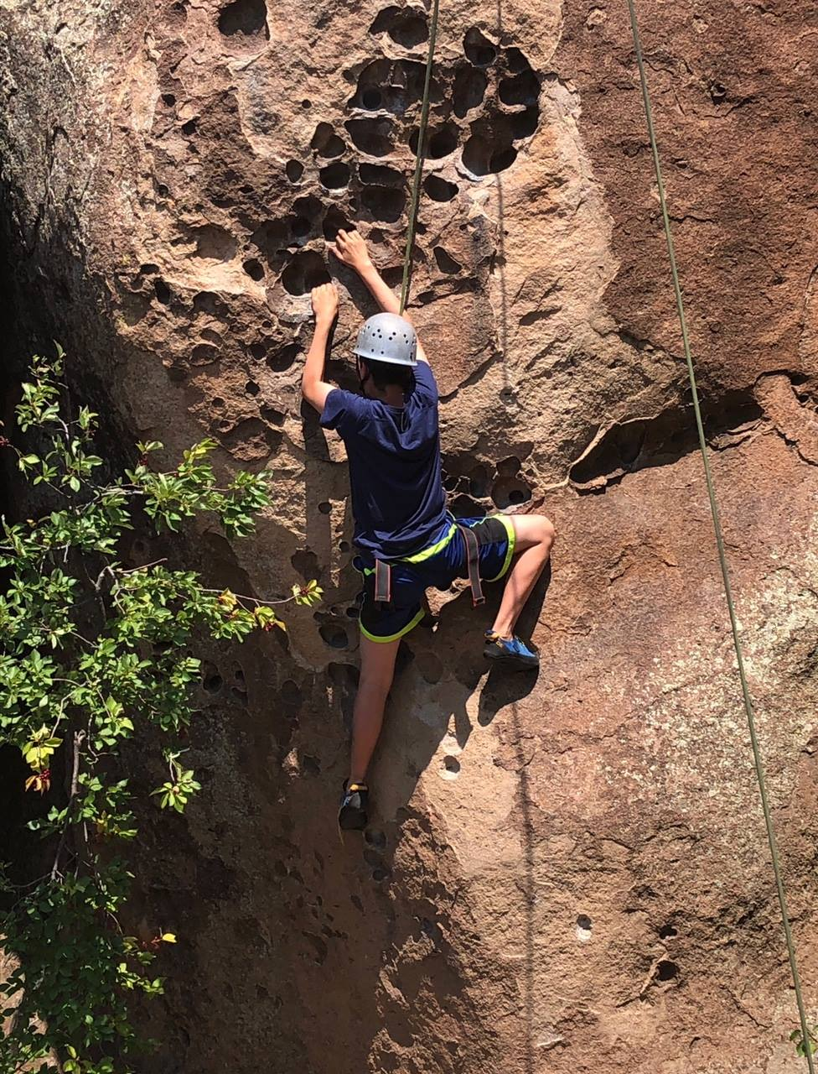
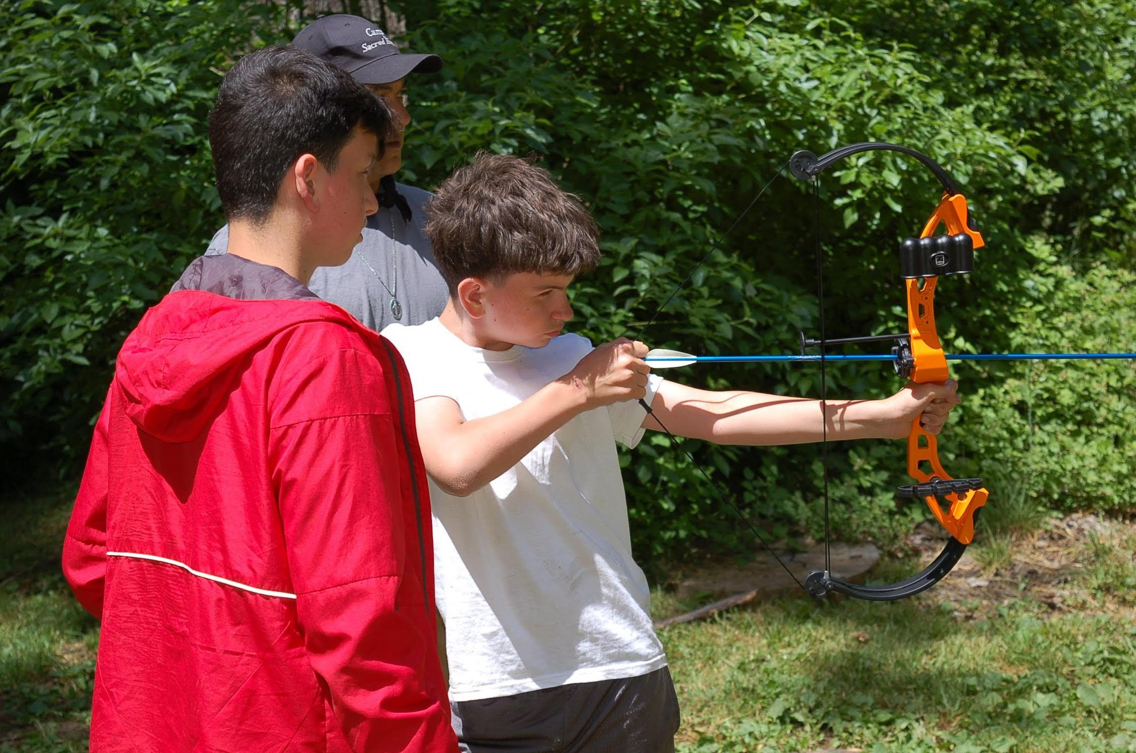

Will and Henry, Archery, Camp Sacred Heart, June 2018

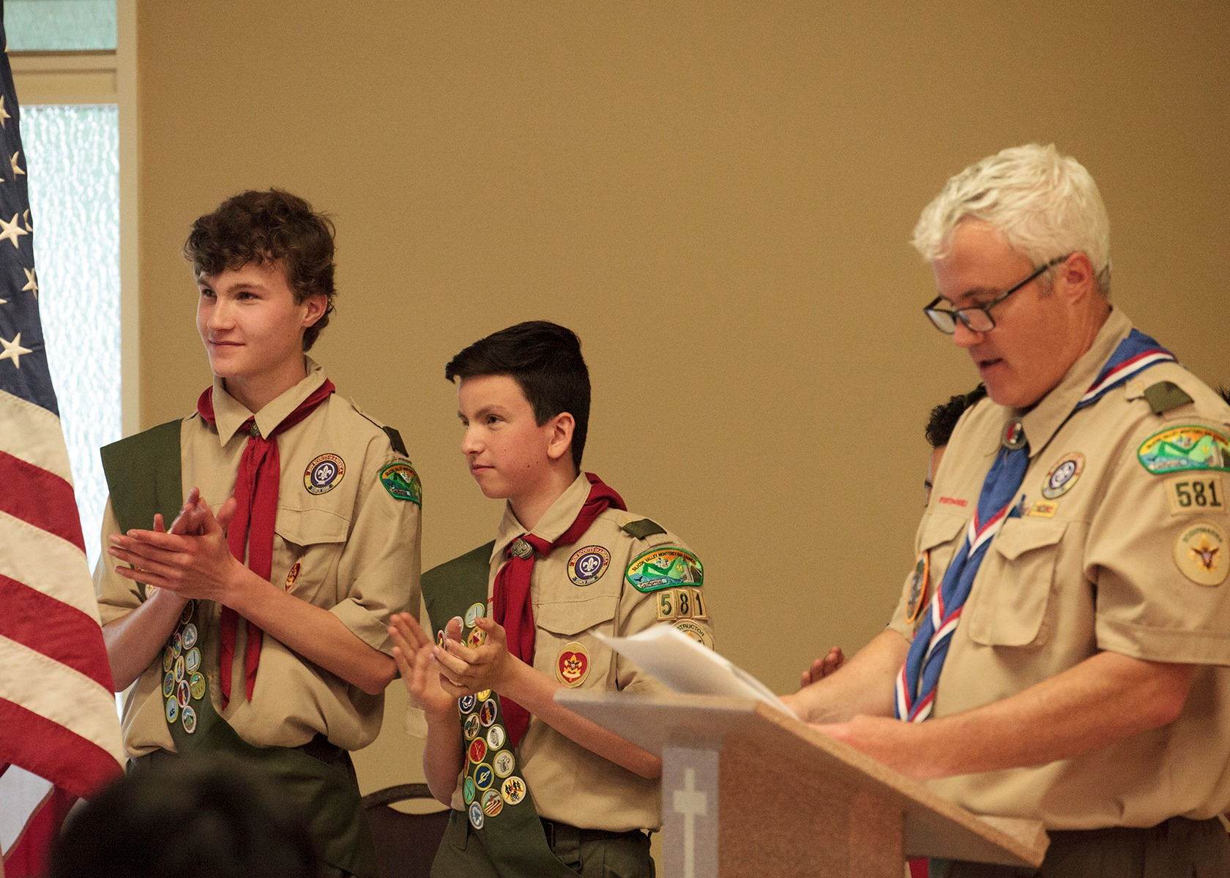

Will elected SPL, after being sworn in by Scoutmaster Bryan Rosevear
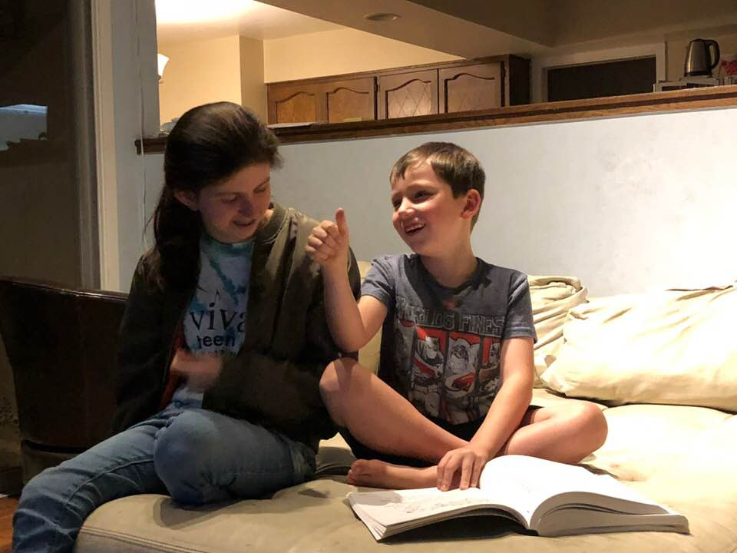

Mark getting reading lessons with Olivia, and doing fabulous
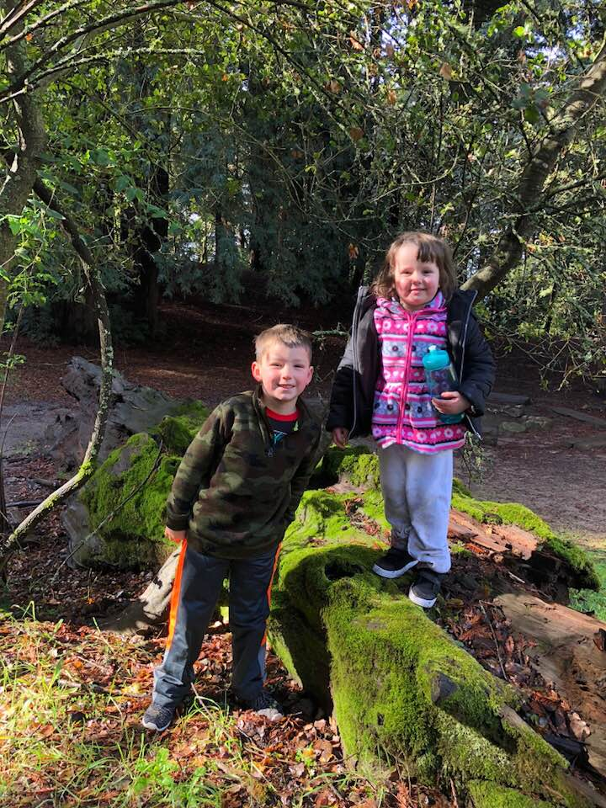
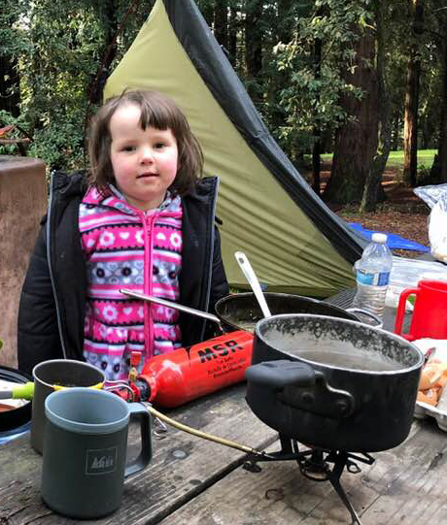

Ellie and Mark camping with Dad (and Troop 581) at Mt. Madonna. It froze!
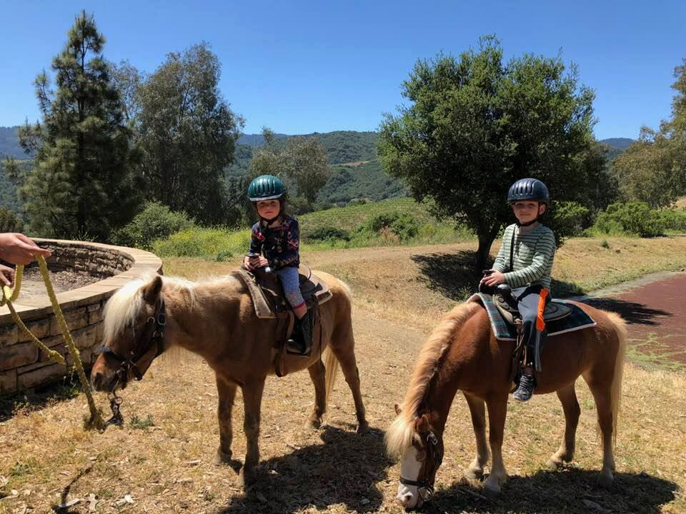

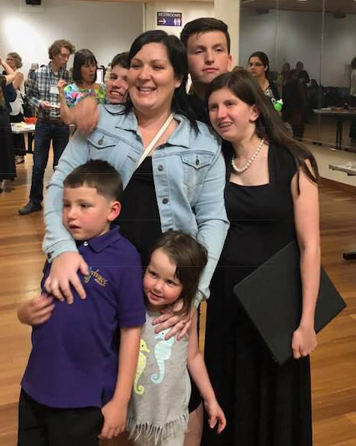
Pony Rides at
Cooper Garrod
May 2018

Four Jennings performed in the
Vivace Youth Chorus Anniversary
Concert – with Vanesa after the
Concert.

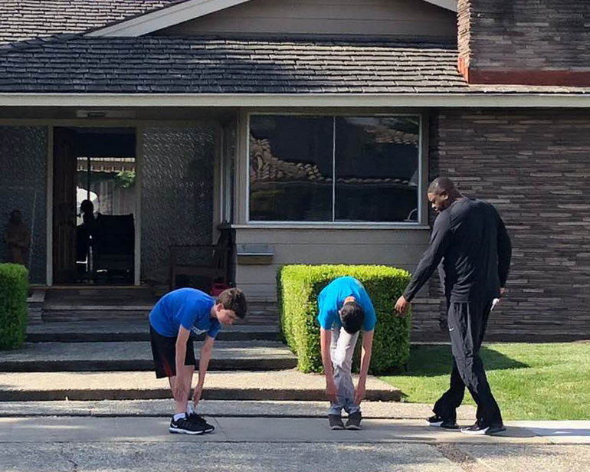

Warm up before Coach runs the lads through the paces
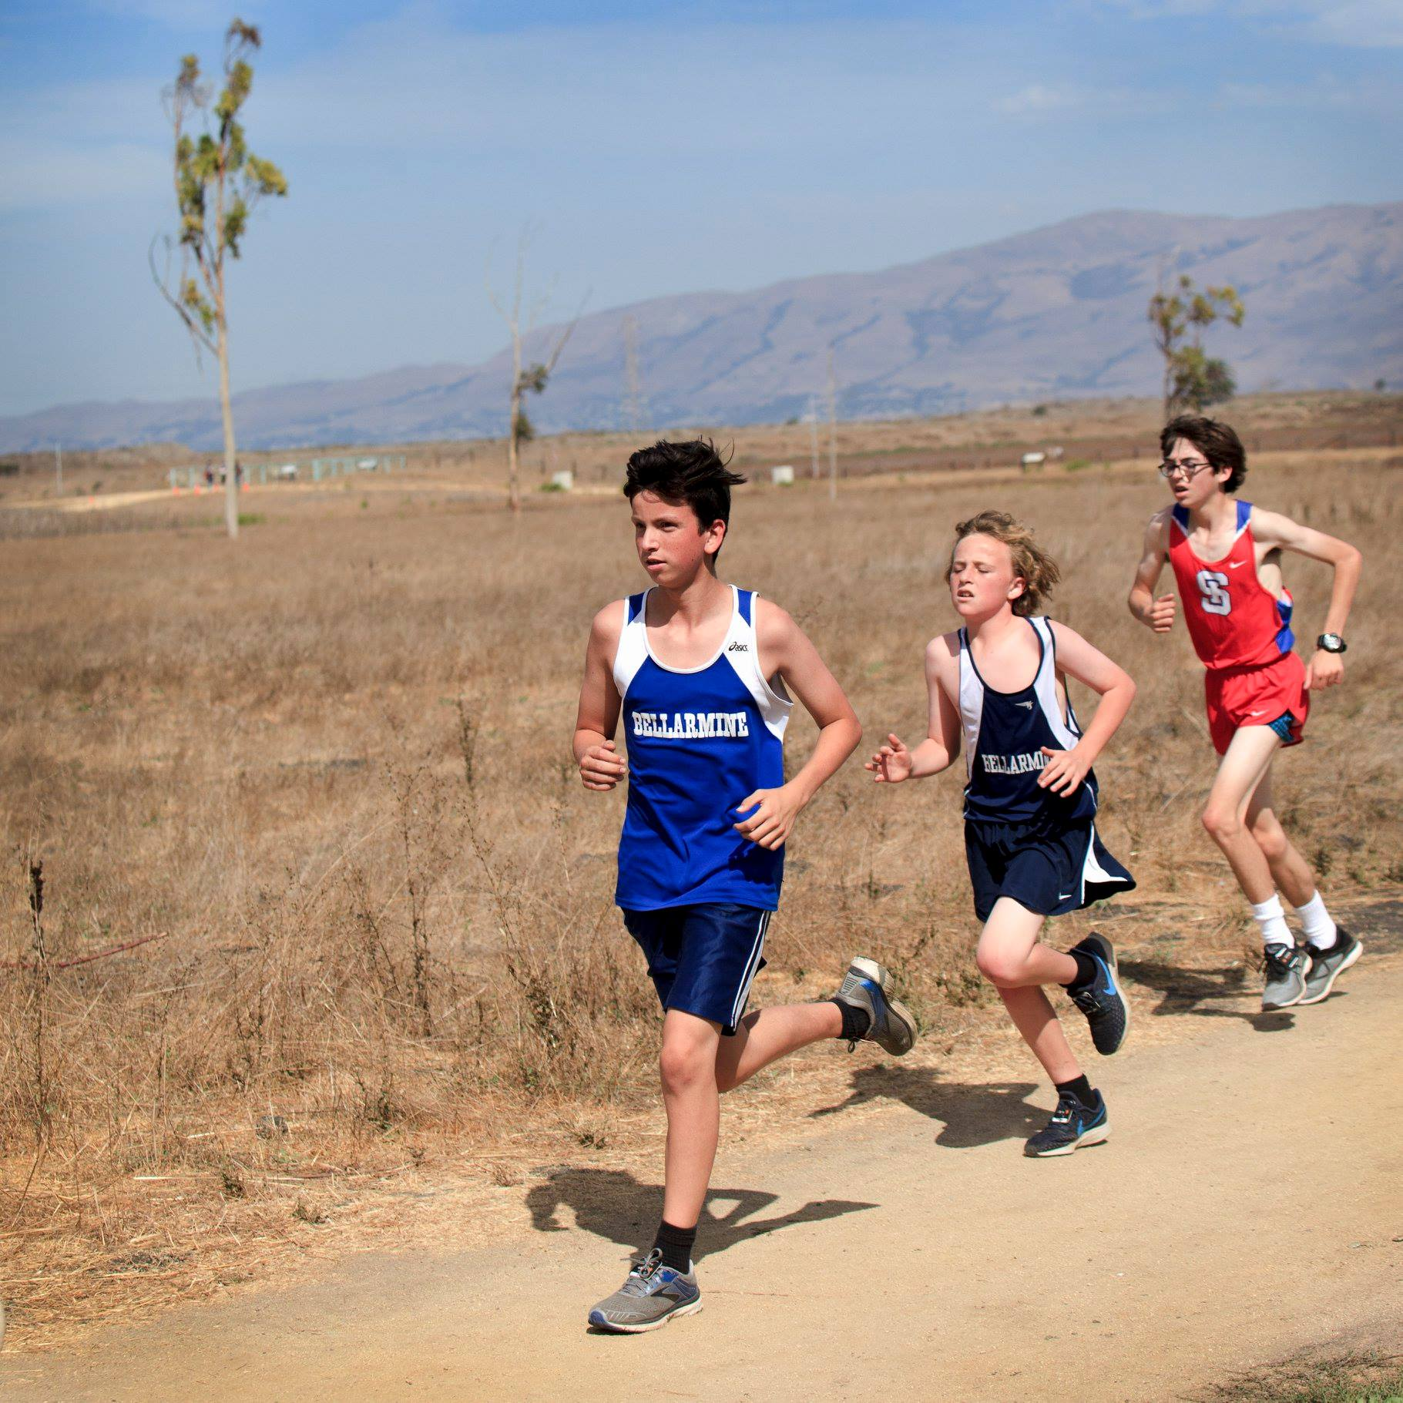

Will at Baylands
running
cross country
for the Bellarmine
team

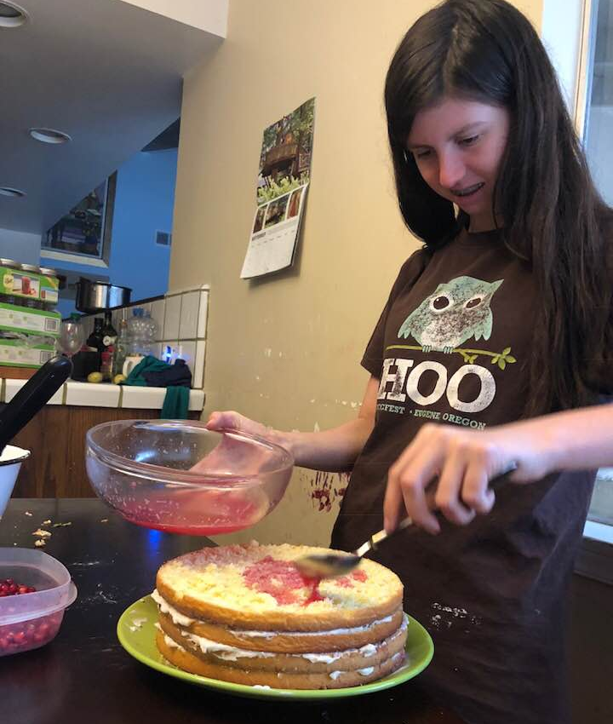
Olivia baking up a
Pomegranate four layer
Cake one weekend afternoon.

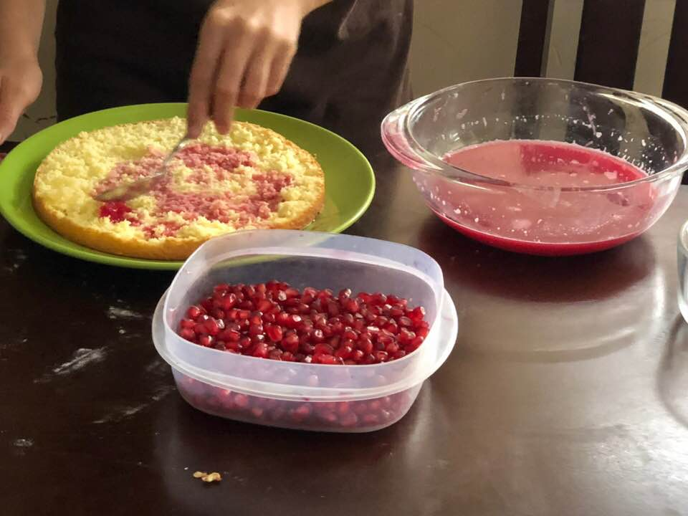

Playing violin
for a retirement home
in San Jose

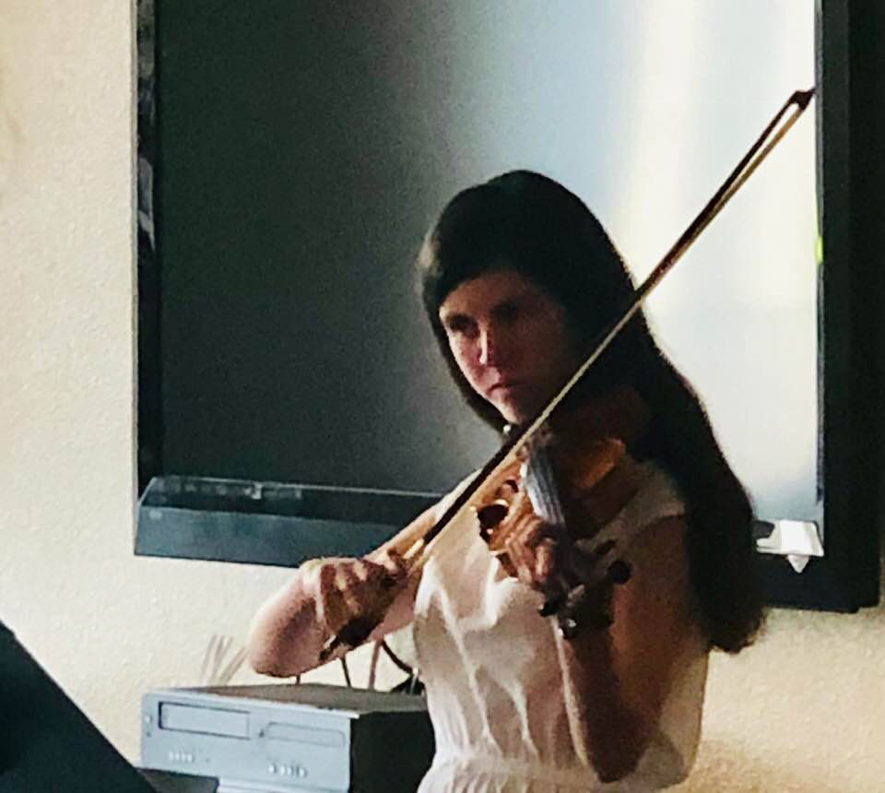

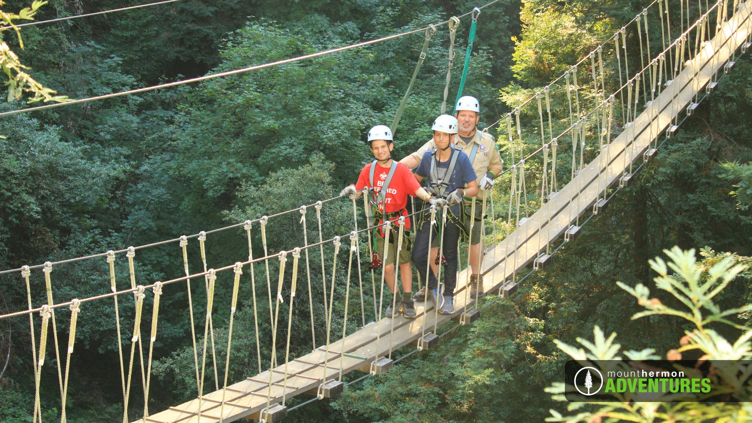

Will, Henry, and Dad enjoying Zip-lining together
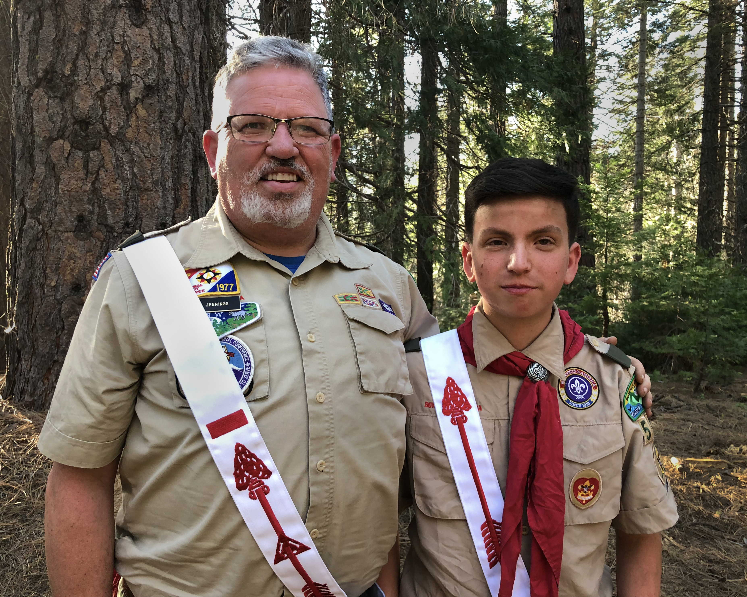

Firm bound in brotherhood, gather the clan
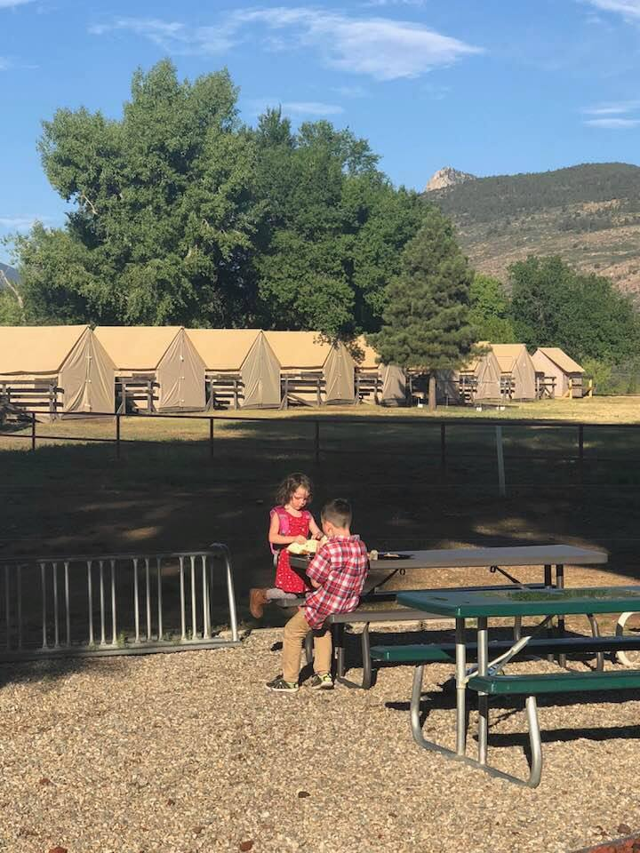
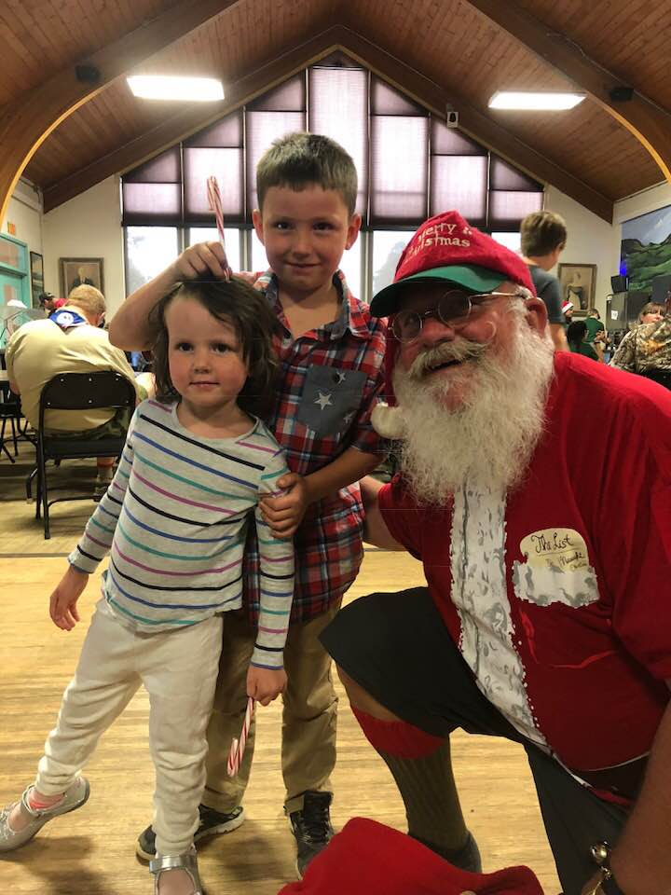
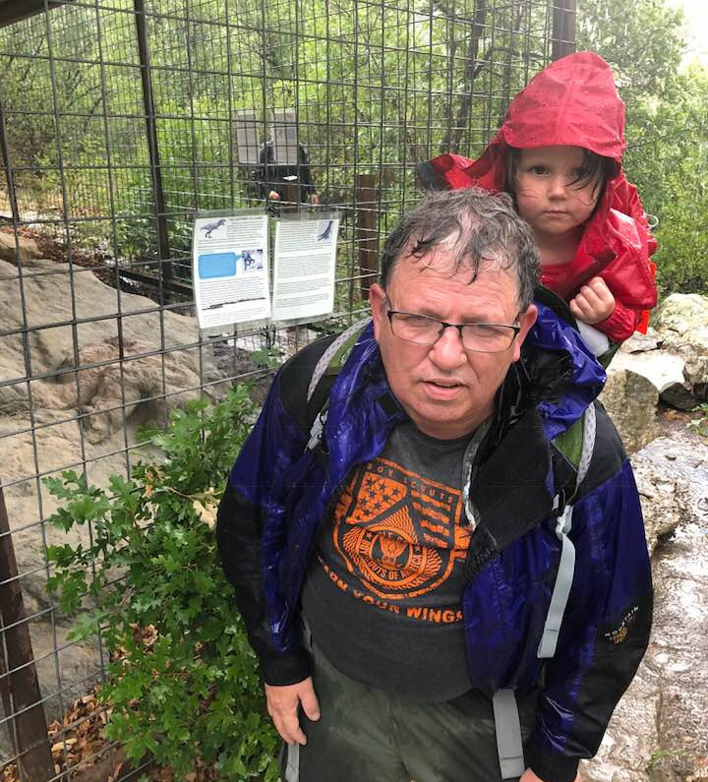
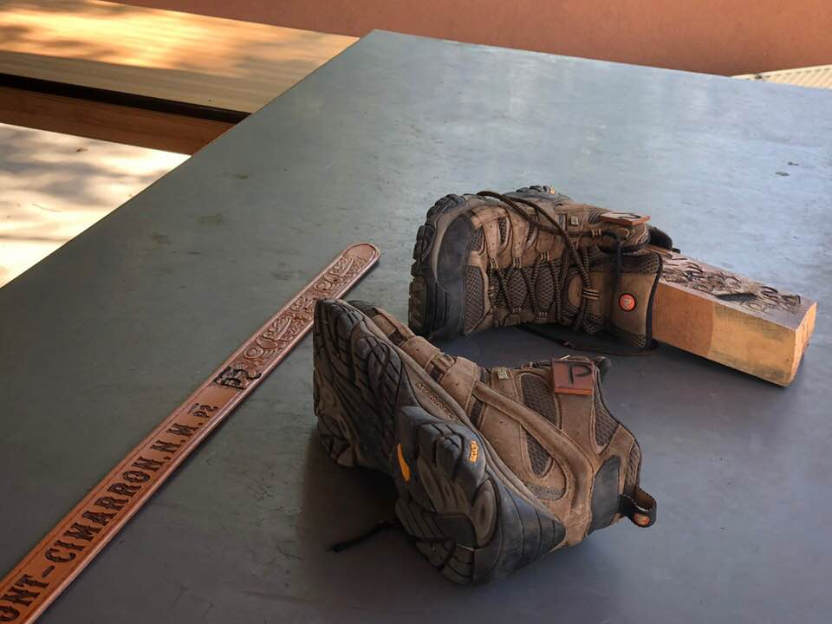
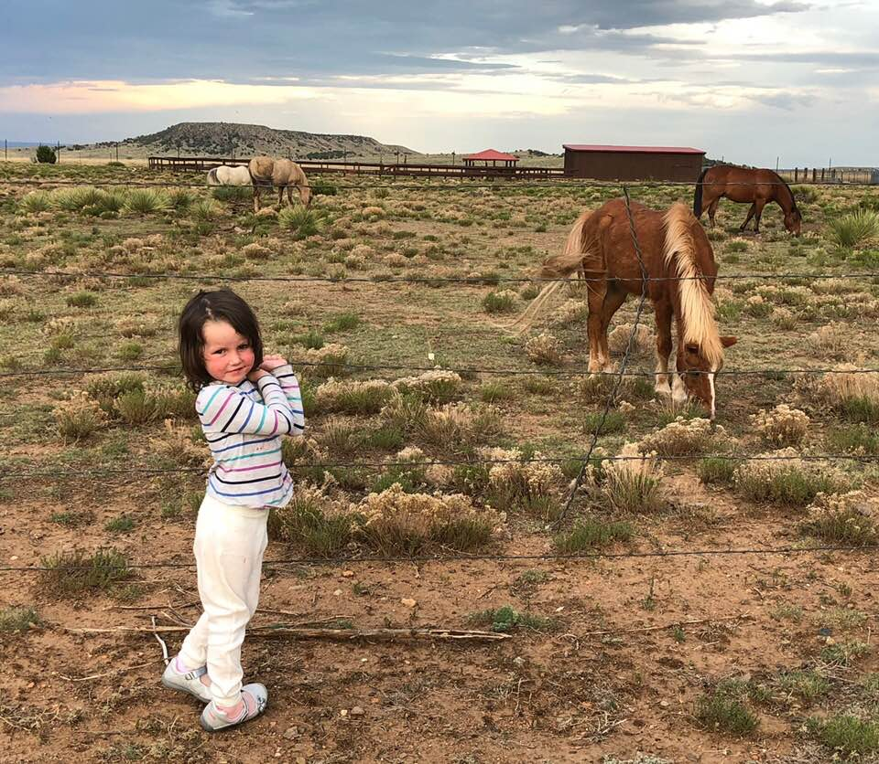
Dad took an Adult Training course at the Philmont Training Center in July 2018. Elizabeth and Mark came with Dad and enjoyed programs during the day: ponies, hiking, bb gun shooting, crafts, and making friends.
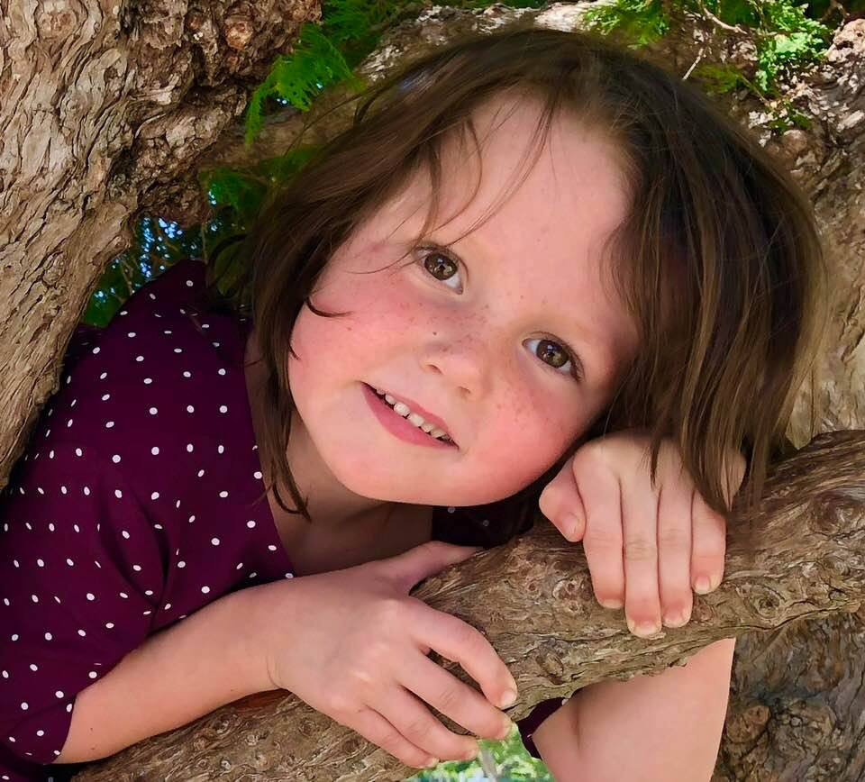

Ellie loves to
climb trees

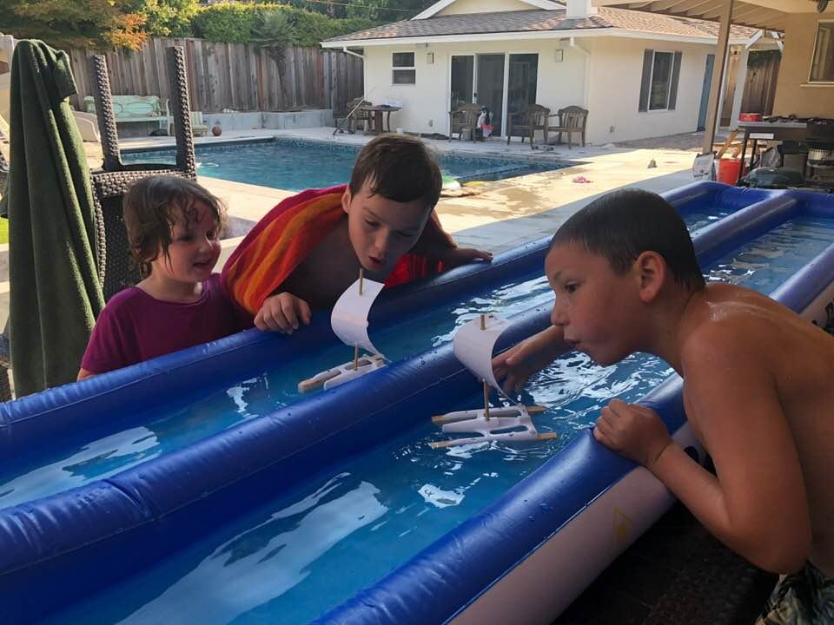

Raingutter Regatta Practice
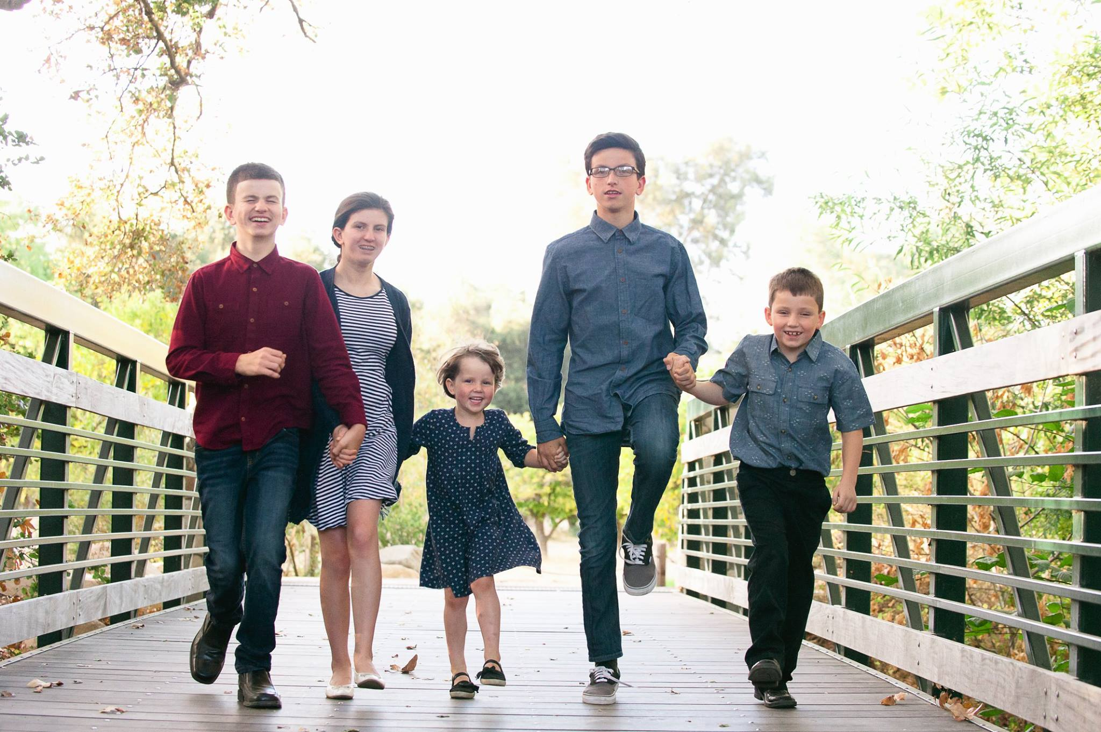

Family photographs in September 2018 at Blackberry Farms, Cupertino
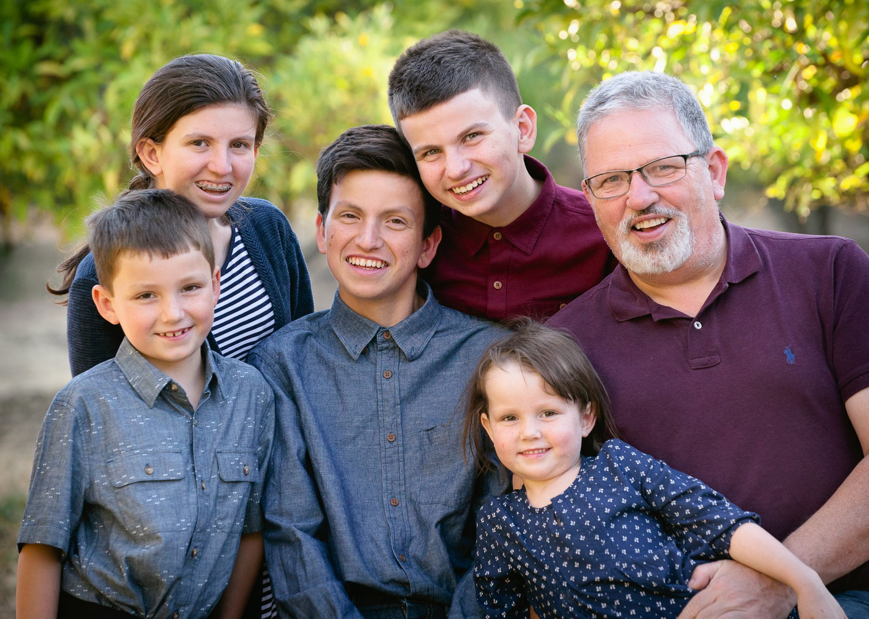

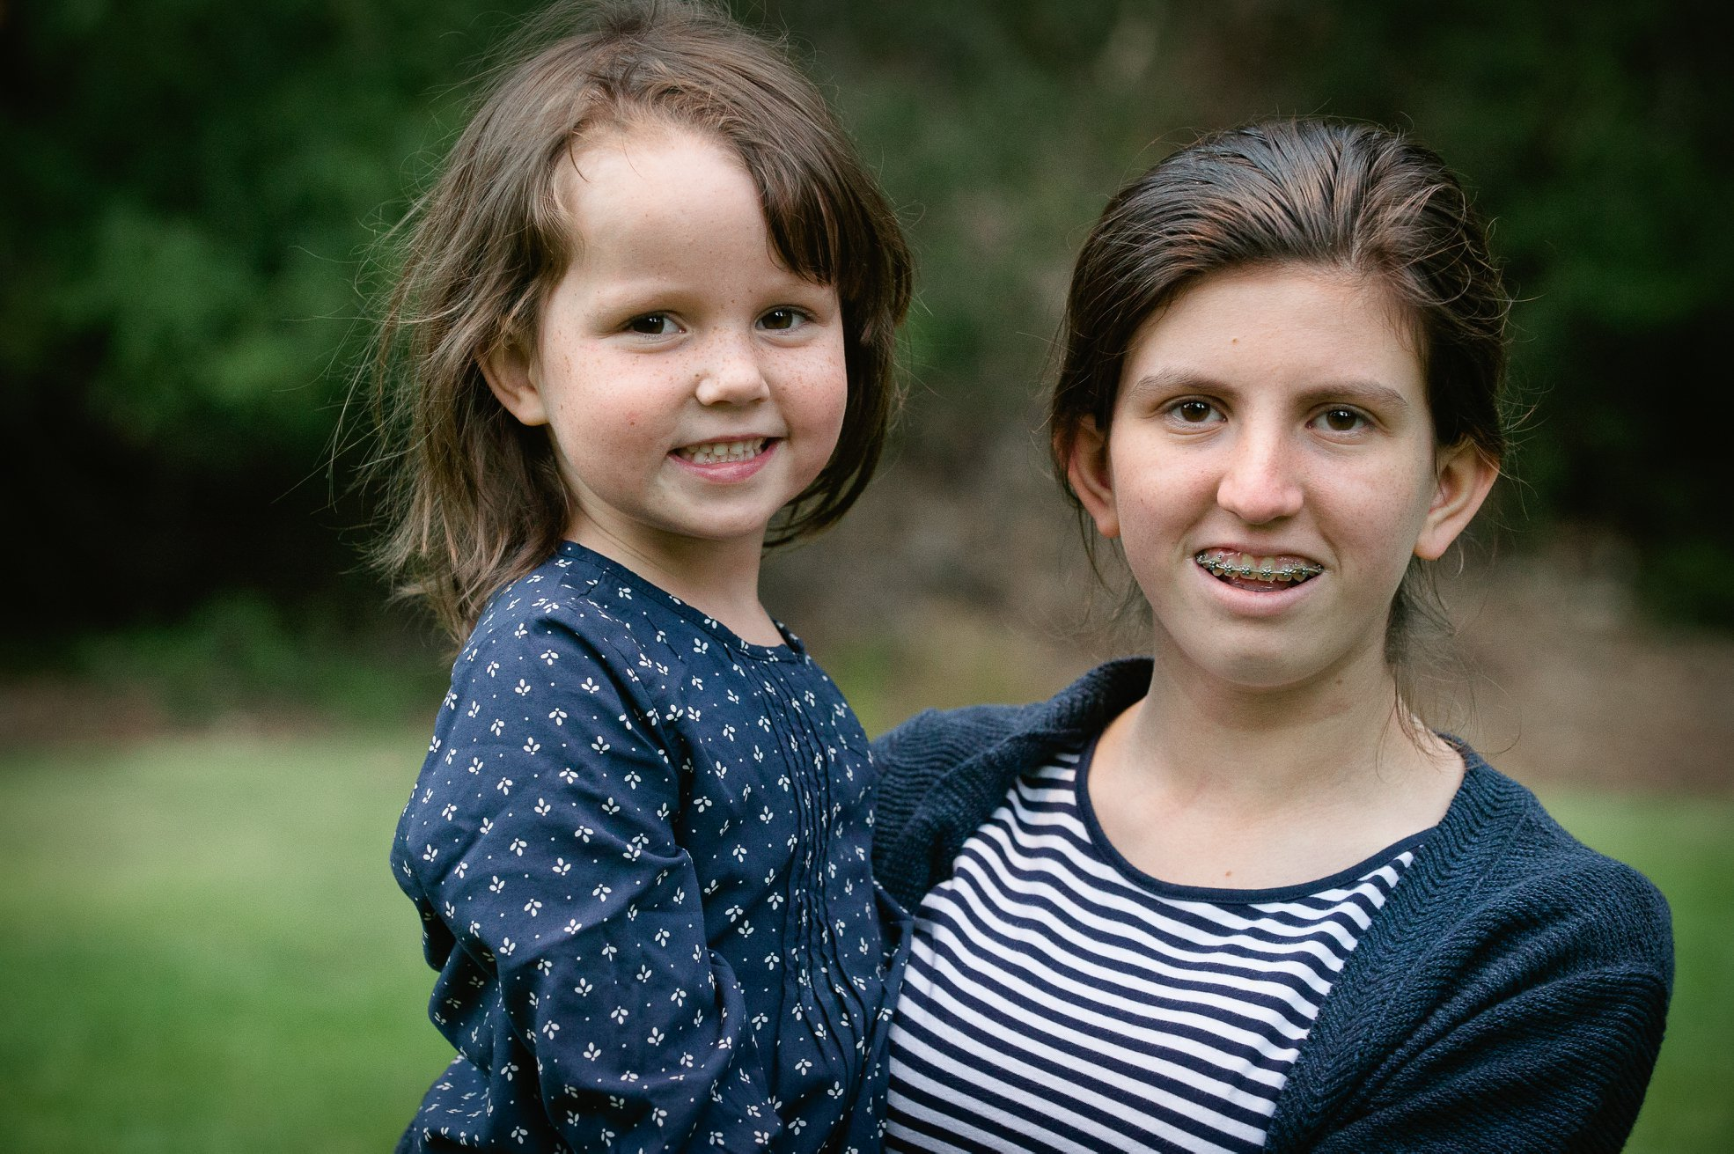
Family photographs in September 2018 at Blackberry Farms, Cupertino
